Homework 4

STAT:3210 Experimental Design and Analysis

Yubing Li

**1. Problem 3.26:**

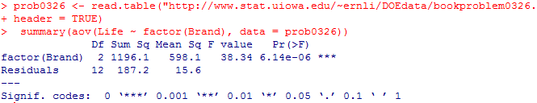(a)

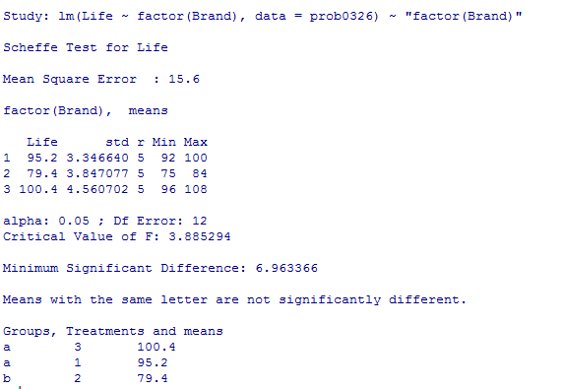

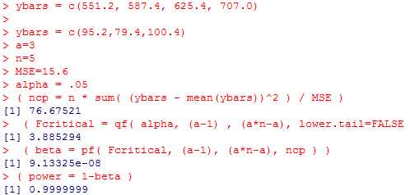1) By hand: The power is 1.

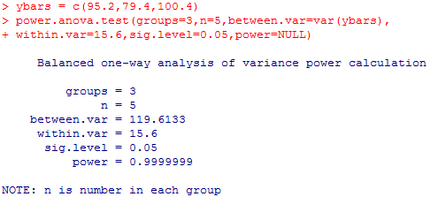2) By power.anova.test: The power is 1. (The results are the same.)

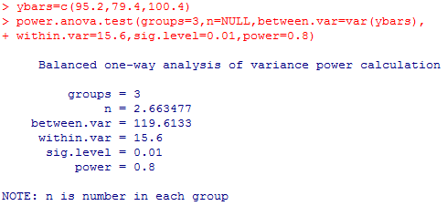(b) The necessary sample size is 3.

**2. Problem 4.4:**

(a) $H_{0}: τ_{1}=τ_{2}=τ_{3}$ vs. $H_{A}: τ_{i}≠0$ for at least one i

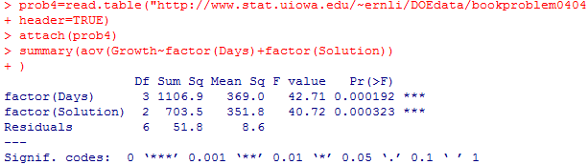Since the p-value is small (< 0.05), we reject the null hypothesis and conclude there exists at least one significant difference among different solutions.

(b) (Plots on the next page)

1) Normality is satisfied because in the normal QQ plot, the residuals are generally goes along the diagonal refrence line closely. Constant variance assumption is also satisfied because in the Residuals vs fitted value plot, there’s no serious departure from constant variance.

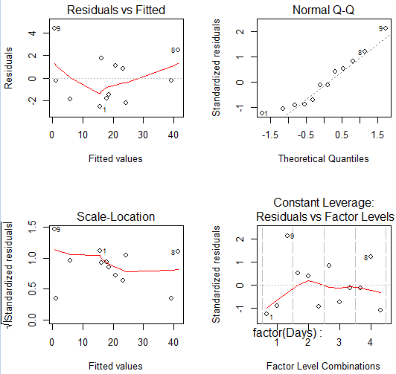

2) Nonadditivity test: (no interaction between two factors vs. there’s interaction)

Since the p-value for interaction term is large and not significant, we fail to reject the null hypothesis and say there’s no need for the extra term.

The nonadditivity assumption is satisfied.

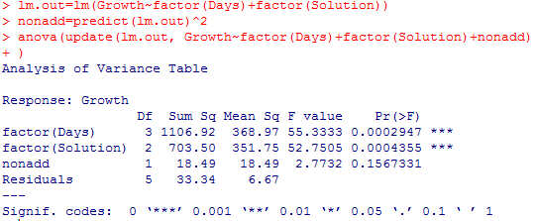3)From the interaction plot, we can clearly see that the three lines are generally parallel with no interactions, which indicates the same treatment differences and block differences. It is consistent with the result we get from the test.

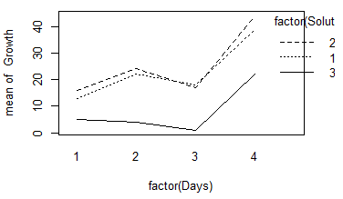

(c) CRD:

The MSE = 128.7 in CRD is biased estimator for $σ^{2}$ in the actual RCBD.

In comparison to the two-way ANOVA, the .

Since we fail to block when we should have, the effect might inflate the rxperimental error and make it harder to identify the differences among treatment means.

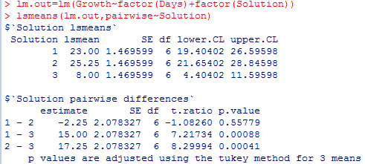(d) Pairwise comparisons HSD: ( $H_{0}: τ_{1}=τ_{2} or τ_{1}=τ_{3} or τ_{2}=τ_{3}$ vs. $H_{A}:$ not $H_{0}$)

Since the p-value for 1-3 and 2-3 are smaller than 0.05, we reject the null hypothesis and conclude there’re significant difference between solution 1, 3 and between solution 2, 3. On the other hand, we fail to reject the null hypothesis for solution 1, 2 and conclude there’s no significant difference between solution 1 and solution 2.

(e) a=3, b=4, ${MS}_{block}=$ 369, ${MS}_{E}=$ 8.6

$${{\hat{σ}}^{2}}_{CRD}=\frac{\left(4-1\right)\left(369\right)+4(3-1)(8.6)}{\left(3\right)\left(4\right)-1}=106.89091$$

$${RE}_{RCBD:CRD}=\frac{\left[\left(3-1\right)\left(4-1\right)+1\right][\left(3\right)\left(4-1\right)+3](106.89091)}{\left[\left(3-1\right)\left(4-1\right)+3\right][\left(3\right)\left(4-1\right)+1](8.6)}=11.60056$$

This number means that approximately 11.60056 times as many replicates would be needed with a CRD to obtain the same sensitivity as obtained by the RCBD.

Since the RE is larger than 1, we conclude that the RCBD is better. The blocking works well.

(f) 1) ${{\hat{σ}}^{2}}_{β}=\frac{{MS}_{blocks}-{MS}_{e}}{a}=\frac{369-8.6}{3}=120.133$

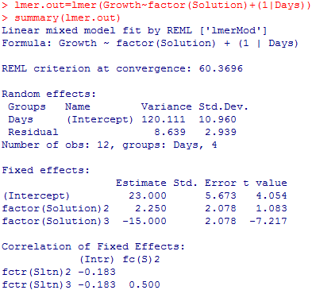2) The ${{\hat{σ}}^{2}}_{β}$ from the fitted model is 120.111. Yes, it is generally the same.

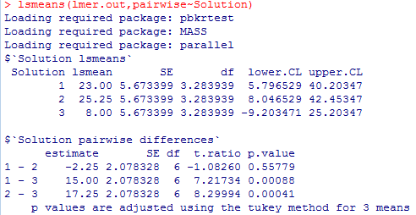3) Pairwise comparisons HSD: ( $H_{0}: τ_{1}=τ_{2} or τ_{1}=τ_{3} or τ_{2}=τ_{3}$ vs. $H_{A}:$ not $H_{0}$)

Since the p-value for 1-3 and 2-3 are smaller than 0.05, we reject the null hypothesis and conclude there’re significant difference between solution 1, 3 and between solution 2, 3. The results of significance for both tests are the same.

The SEs in this test (=5.7634) is greater than the previous test (=1.4696) because the random variations among blocks are included. However the variations are canceled out when we do contrasts. The pairwise comparison results are the same (SE=2.0783).

(g) To get a power of 0.9146, we would need at least 8 blocks.

(R output on the next page)

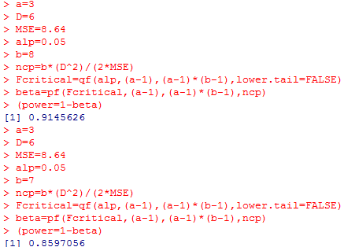

< 8 blocks get a power of 0.9146

< 7 blocks get a power of 0.8597

(h) $H_{0}: τ_{1}=τ_{2}=τ_{3}$ vs. $H_{A}: τ_{i}≠0$ for at least one i

Since the p-value = 4.62*10^-5 is small (< 0.05), we reject the null hypothesis and conclude there exists at least one significant difference among different solutions.

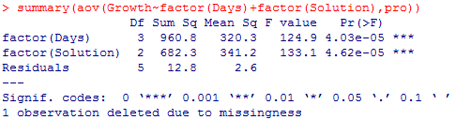

**3. Problem 4.7:**

(a) $H_{0}: τ_{1}=τ_{2}=τ_{3}=τ_{4}$ vs. $H_{A}: τ_{i}≠0$ for at least one i

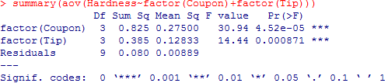Since the p-value is small (< 0.05), we reject the null hypothesis and conclude there exists at least one significant difference among four different tips.

(b) Fisher LSD: (R output on the next page)

( $H_{0}: τ_{i}=τ_{i'} for any i and i'$ vs. $H_{A}:$ not $H_{0}$)

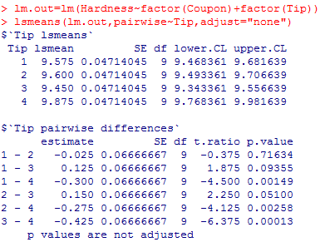Since the p-value for 1-4, 2-4 and 3-4 are smaller than 0.05, we reject the null hypothesis and conclude there’re significant difference between tip 1, 4; between tip 2, 4; and between tip 3, 4. In general, tip 4 is very different among other tips in mean hardness readings.

(c)

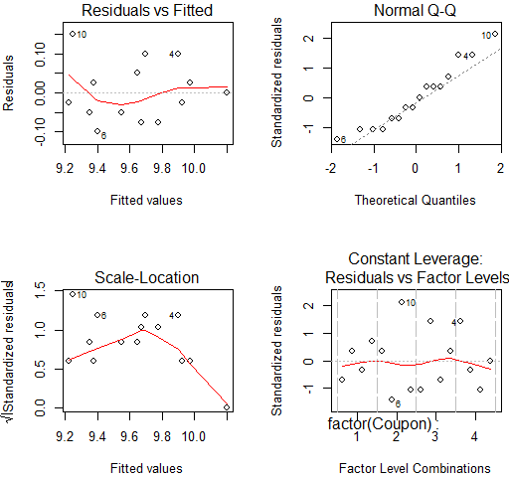

Normality is satisfied because in the normal QQ plot, the residuals are generally goes along the diagonal refrence line closely. Constant variance assumption is also satisfied because in the Residuals vs fitted value plot, there’s no serious departure from constant variance. Independence is satisfied, there’s no obvious pattern for residuals.

(d) Nonadditivity test: ($H_{0}:$ no interaction between two factors vs. $H_{A}:$ there’s interaction)

Since the p-value for interaction term is large and not significant, we fail to reject the null hypothesis and say there’s no need for the extra term.

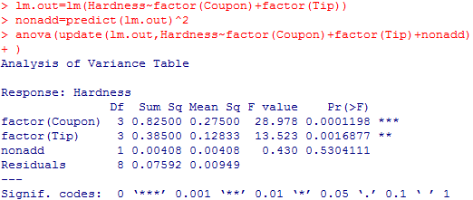The nonadditivity assumption is satisfied.

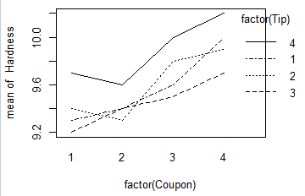(e) Generally speaking, the 1, 2, 3 lines have some interaction. The plot is not very agree with the result from the test.

(f) a=4, b=4, ${MS}_{block}=$ 0.275, ${MS}_{E}=$ 0.00889

$${{\hat{σ}}^{2}}_{CRD}=\frac{\left(4-1\right)\left(0.275\right)+4(4-1)(0.00889)}{\left(4\right)\left(4\right)-1}=0.062112$$

$${RE}_{RCBD:CRD}=\frac{\left[\left(4-1\right)\left(4-1\right)+1\right][\left(4\right)\left(4-1\right)+3](0.06211)}{\left[\left(4-1\right)\left(4-1\right)+3\right][\left(4\right)\left(4-1\right)+1](0.00889)}=6.71801$$

This number means that approximately 6.71801 times as many replicates would be needed with a CRD to obtain the same sensitivity as obtained by the RCBD.

Since the RE is larger than 1, we conclude that the RCBD is better. The blocking works well.

(g) 1)

2) The from the fitted model is 0.06653. Yes, it is generally the same. (on the next page)

3) Pairwise comparisons LSD: $H_{0}: τ_{i}=τ_{i'}$ (for any i and I’) vs. $H_{A}:$ not $H_{0}$

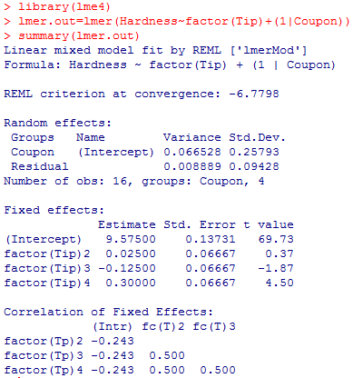

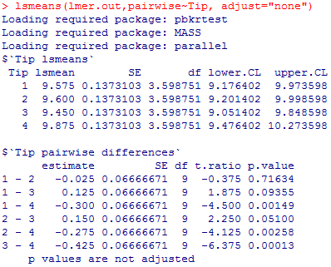LSD:

Since the p-value for 1-4, 2-4 and 3-4 are smaller than 0.05, we reject the null hypothesis and conclude there’re significant difference between these pairs. Tip 4 is very different. The results of significance for both tests are the same.

The SEs in this test (0.1373) is greater than the previous test (0.04714) because the random variations among blocks are included. However the variations are canceled out when we do contrasts. The pairwise comparison results are the same (SE=0.06667).

(h) $H_{0}: τ_{1}=τ_{2}=τ_{3}=τ_{4}$ vs. $H_{A}: τ_{i}≠0$ for at least one i

Since the p-value = 0.00433 is small (< 0.05), we reject the null hypothesis and conclude there exists at least one significant difference among different tips.

